Service Request Guide: Neuromodulation Service (NMS)

Service Request Process
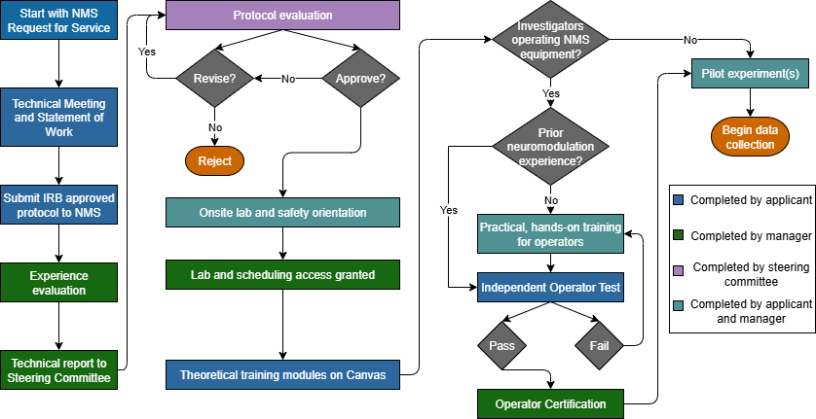
*
*Protocols may be submitted to the NMS prior to IRB approval if the investigator is requesting NMS assistance with protocol development. Documentation of IRB approval will be required before onsite lab orientations and trainings begin.

Laboratory Manager:
Cameron Casey
Email: cpcasey3@wisc.edu or nms@waisman.wisc.edu

NMS Service Request Guidelines
- The applicant must be a faculty member at the University of Wisconsin-Madison and the Principal Investigator (PI) or Senior Supervisor of the project.
- Before requesting NMS services, The PI and all other listed investigators who will conduct experiments MUST read the instructions in this document, including all appendices.
- The applicant must complete the NMS Request for Service Form and submit it to nms@waisman.wisc.edu. The study team will then complete a technical meeting with NMS staff that will guide the drafting of a study-specific Statement of Work (SOW).
- (Optional) If you are requesting NMS support with protocol development, we will work with you to draft neuromodulation protocol language at this stage.
- After acquiring IRB approval for your protocol, you will submit the IRB approval correspondence and full protocol to nms@waisman.wisc.edu.
- The lab manager will evaluate the experience/competency of the PI and all other listed investigators who will conduct experiments according to the “NMS Investigator Competency Criteria” (Appendix 1), and then send a report to the NMS Steering Committee.
- The NMS Steering Committee will review the report and the experimental protocol and make a decision accordingly. The NMS Steering Committee may request that the PI revise the protocol or may reject the application, due to safety or technical concerns.
- If the NMS Steering Committee approves the protocol, the investigators who conduct the experiment will receive an “NMS Orientation and Equipment Operation Training” (Appendix 2) provided by the lab manager.
- IF The study team will be operating NMS equipment:
Before the PI receives technical approval, any lab members who will operate NMS equipment must pass the “Independent Operation Test” (Appendix 3). If they fail to pass the test, they will need to schedule more training and practice until they pass the test.

Appendix 1.
NMS Investigator Competency Criteria
- Investigators should have experience in conducting the related experiment as a primary operator in at least one project or at least 10 hours of total operation time. Experience must be in the same modality (TMS or tES) as the planned study, i.e., prior tES experience does not count towards TMS certification and vice versa.
- Investigators should have essential knowledge of how to set up and operate the requested equipment.
Specifically:
- For TMS: the investigators should have the knowledge of how to set the parameters of different testing protocols (e.g., single pulse intensity, inter-stimulus interval and conditioning intensity). Also, investigators should be competent to examine the resting motor threshold and locate the TMS hotspot using TMS coils.
- For rTMS: the investigators should understand how to set the parameters of different interventions (i.e. pulse number, intervention duration, pulse rate, train number, and waiting time). The investigators should have competence examining resting motor threshold and locating the TMS hotspot using rTMS coil (air film coil). Also, the investigators should have knowledge of the consequences/effects that will be induced by different interventions.
- For TMS or rTMS: the investigators should have knowledge of how to acquire EMG signals. This includes: preparing the skin, attaching electrodes, checking signal quality and recognizing MEPs from stimulation, artifacts, and noise.
- For tDCS: the investigators should have knowledge of how to attach electrodes, the safety range of current intensity and the consequence/effect that will be induced by different setup and protocols.
- For BrainSight Neuronavigation: the investigators should have knowledge of how to input images into the system, render 3D models (skin and brain), set markers & trajectories, register participants, calibrate coils, locate neuronavigation targets with a coil, maintain accuracy, and record coil location data.

Appendix 2.
NMS Orientation and Equipment Operation Training
To help investigators:
- Become familiar with the NMS neuromodulation platform(s):
  - For TMS: Learn how to use the TMS/rTMS parameter setting system, the customized data acquisition system, and the structure of the stored data
  - For tES: Learn how to use the tES equipment
- Become familiar with the regulation of the NMS, including rules to use the public shared facilities (e.g., tables, chairs, computers, etc.) and lab supplies (e.g., conductive gel, medical tape, alcohol wipes, etc.).
Details:
Purpose 1:
- How to reserve the room on CTC website
- Where the restrooms are for participants and study staff
- Do NOT enter testing rooms in use by other studies
- Do NOT block the hallway or run in the research area
Purpose 2:
- How to connect trigger/signal cables for the requested protocols
- Regulations to use the equipment to prevent damage
- Equipment locations and set up
Purpose 3:
- Assign a storage space if needed and available
- Dedicated location/space of the essential facilities/supplies in the lab
- How to clean/clear lab equipment after experiments
- Regulations to use the lab facilities (Appendix 4)

Appendix 3.
NMS Investigator Independent Operation Test
Purpose: To test if the investigators are competent to conduct experiments independently in an appropriate manner.
Test items:
- Know how to reserve the lab space on the CTC scheduling calendar.
- Equipment location: know the locations of the requested equipment.
- Trigger/signal/control cable connection: know how to connect the trigger/signal cable correctly.
- Connect TMS coils correctly.
- Turn on the machine/program in the correct order.
- Know how to solve common problems (e.g., notice and correct improperly connected TMS coils, trigger/signal/control cables, etc.)
- Ability to solve noise problems in EMG data (e.g., check electrode placement, reapply the ground, etc.)
- Collect data independently and correctly.
- Understand that no PHI (Appendix 5) can be entered onto the computers in NMS.
- Know how to convert data into Matlab/Excel readable form.
- Clean up equipment after experiment: wipe chair, throw away used tape, electrodes, alcohol wipes, etc.
- Put equipment back in dedicated locations.
- Unplug equipment after experiment.
- Know how to call 911 for emergencies.
- Know how to report equipment/hardware damage or software/program error.

Appendix 4.
NMS Regulations
- The NMS is not responsible for the safety of the participants or investigators. Investigators use the equipment in NMS at their own risk.
- The Principal Investigator (PI) is responsible for providing supervision of project staff, the safety of research participants and staff, and correct operation of lab equipment.
- For emergencies, call 911 and follow the proper emergency response procedures. For other issues, please contact the lab manager (Cameron Casey, Email: cpcasey3@wisc.edu or nms@waisman.wisc.edu ).
- At least two study team members are required to be present throughout the experiments.
- Per the PI’s request, investigators will be given access to the Waisman Center during off-hours. The PI will remain responsible for all aspects of research activity by their students and staff. Please contact the lab manager to request off-hours access.
- Investigators operating NMS equipment must hold a valid CPR certificate.
- Undergraduate students are NOT permitted to operate TMS (i.e., drive the TMS coil during stimulation). Undergraduate students may assist with other aspects of neuromodulation experiments such as material preparation and data collection. During experiments, undergraduate students must always be accompanied by a staff or faculty member on the study team (e.g., the Principal Investigator).
- Report any adverse events to the lab manager and PI immediately after completing emergency response procedures.
- Project schedulers should schedule all experiments on the CTC Portal Scheduling System before using the space and facilities.
- Do NOT leave a research participant unattended.
- Do NOT take equipment/supplies out of the NMS unless approved by the lab manager.
- Do NOT use any equipment/device that does not belong to the NMS, unless approved by the lab manager.
- Only use the room you scheduled on the CTC Portal, and only for the time window in the reservation. Do NOT deny other researchers access to the space if your experiment takes longer than the reserved time slot.
- The NMS does NOT provide disposable experiment supplies (e.g. disposable electrodes, alcohol wipes, tapes, conductive gel, etc.). Investigators should purchase their own disposable supplies. Limited storage is available in the NMS and will be assigned to research teams when available, but investigators may need to arrange to store study supplies elsewhere.
- Before an experiment, check the status of the equipment. Please report any damage or software errors to the lab manager.
- After an experiment, return all equipment/devices back to the dedicated places. Shut down equipment, unplug all power cords, and lock the door when done.
- No PHI (Appendix 5) should be entered into the computers in NMS.
- Investigators are responsible to copy the data from each experiment immediately after use. The NMS will wipe the experiment data periodically without notification.

Appendix 5.
Protected Health Information (PHI) definition
PHI is protected health information, as defined by applicable IRB and University policies.
At a minimum, PHI includes the following:
- Name, initials
- All geographic subdivisions smaller than a state (street address, city, county, precinct) Note: you can retain the first 3 digits if the zip code area contains more than 20,000 people.
- For dates directly related to the individual, all elements of dates, except year (date of birth, admission date, discharge date, date of death).
- All ages over 89 or dates indicating such an age, except that you may have an aggregate category of individuals 90 and older.
- Telephone number
- Fax number
- Email address
- Social security number
- Medical record number
- Health plan number
- Account numbers
- Certificate or license numbers
- Vehicle identification/serial numbers, including license plate numbers
- Device identification/serial numbers
- Universal resource locators
- Internet protocol addresses
- Biometric identifiers, including finger and voice prints
- Full face photographs and comparable images
- Any other unique identifying number, characteristic or code.

